Actual CONTRACTS / CONTRACT Resources

Sam.gov (system for award management) lists these RFI’s and other contract related stuff..currently there’s one on their for fission surface power systems form nasa. Check SAM.gov with keywords like DOE nuclear space power, fission, reactor, HALEU.
SBIR.gov (Participating Agencies post SBIR/STTR funding opportunities on a regular periodic basis throughout the year. Some agencies have multiple solicitations throughout the year, while others may only have one solicitation release each year. Once you identify a relevant agency to target, learn more about that specific agency's process.)

Tips on Using These Links Effectively
- Create a SAM.gov account and save keyword alerts — you’ll get emails for new opportunities.
- Follow DARPA BAAs — these often open creative R&D work that doesn’t fit classic procurement patterns.
- Use SBIR.gov to find small business windows from multiple agencies in one place.
- SpaceWERX + DIU are excellent for fast prototyping programs and OTAs (especially for startups).
- NASA centers (like Glenn) often post industry days before official SAM.gov releases.

Actual Contracts

NASA = https://sam.gov/workspace/contract/opp/ff7181661cb94e6fa0fb14ca89013730/view?utm_source=chatgpt.com. Fission Power System . NASA has a Fission Service Power Page with POC’s / requirements…https://www.nasa.gov/glenn/fsps/? NASA FSP = NASA’s Fission Surface Power program, aimed at deploying small nuclear reactors on the Moon, with DOE and industry building the actual hardware. Fission Surface Power (FSP) is a formal technology-development program led by NASA in partnership with the Department of Energy. Its mission:

Develop a small fission reactor power system that can operate on the Moon (and later Mars) to support:
• long-duration surface missions
• human habitats
• ISRU (in-situ resource utilization)
• science operations
• cislunar infrastructure

Think of FSP as the umbrella effort under which studies, contracts, lab work, and industry competitions all live.

utm_source=chatgpt.com. Name: Matthew Evans Title: Agreements Officer
Email: Matthew.T.Evans@nasa.gov

Name: Linda Nabors Title: Agreements Officer Email: Linda.M.Nabors.@nasa.gov

DARPA = https://sam.gov/opp/4bc82ea5fe8941dba8f74364147d5631/view — Their tactical technology office has an RFI on on-orbit Nuclear power concepts. The Defense Advanced Research Projects Agency (DARPA) Tactical Technology Office (TTO) is requesting information regarding technologies, spaceflight qualification testing, safe handling, and applications for on-orbit satellite nuclear power systems. Our focus is on producible, cost-effective nuclear reactors – not bespoke designs suited for a one-time demonstration. DARPA TTO and the Department of Energy (DOE) will also hold a workshop (April 21-22) to establish a common understanding of on-orbit nuclear power technology and challenges, facilitate community interactions and collaboration, and identify key technology risk areas that, if addressed, would enable practical implementation of on-orbit nuclear power. Their TTO often puts out BAA’s that you can find on https://sam.gov/opp/109aceb76198452b91f8ecce72b4890b/view

SpaceWerx = The Small Business Innovation Research (SBIR) program enables small businesses to explore their technological potential and provide the incentive to profit from its commercialization by partnering with Space Force units. The SBIR program’s counterpart, Small Business Technology Transfer (STTR), offers an opportunity for university teams (undergraduate, graduate, doctorate, post-doctorate, faculty/staff) who have formed companies and partnered with a university or non-profit entrepreneurial development organizations to do business with the Space Force.

DOW= DoW uses the Broad Agency Announcement (BAA) funding mechanism to procure basic and applied research via issuing topics for scientific study and experimentation, which are directed towards advancing the state-of-the-art, increasing knowledge, or understanding, instead of focusing on, a specific system or hardware solution. In some instances, a DoW component may elect to release topics under a Commercial Solutions Opening (CSO), which is a competitive acquisition procedure for innovative commercial items, technologies, or services. DOW releases the firs weds of every month. It allows DoW to obtain solutions or potential new capabilities to fulfill requirements, close capability gaps, or provide potential technological advancements. Throughout the fiscal year, DoW issues three pre-scheduled SBIR and STTR BAAs/CSOs, through which participating components have an opportunity to publish topics that seek innovative solutions from small businesses, usually in response to national security challenges. https://www.defensesbirsttr.mil/SBIR-STTR/Opportunities/

DOW BAA Schedule
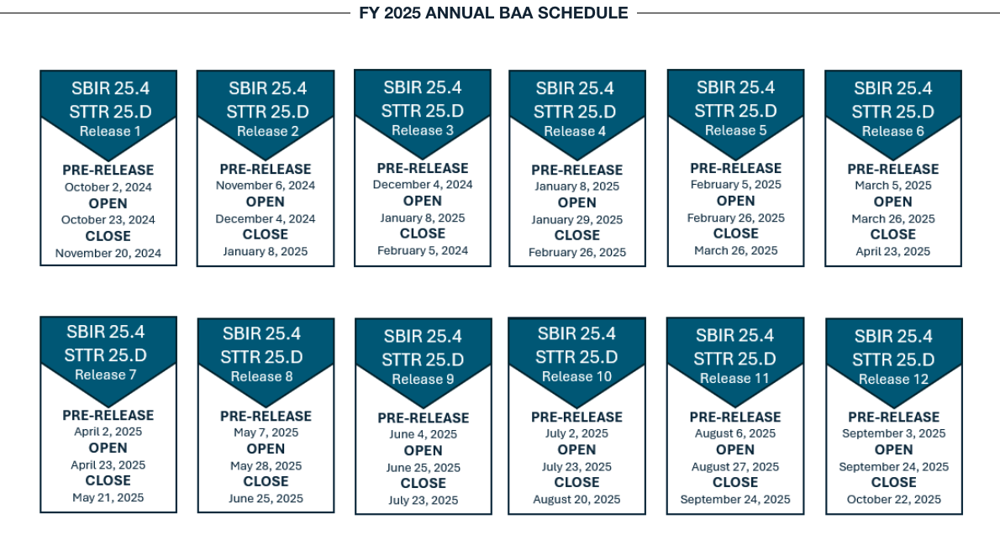

DoD Terrestrial Microreactor Programs (Project Pele, Janus)

These are not strictly “space” but are worth mentioning because they show how DoD nuclear efforts spill over into space-related capability ecosystems:
• Project Pele — DoD mobile microreactor development for remote bases (~1–5 MWe).
• Janus Program — U.S. Army initiative to install microreactors on installations, which could cross over into broader DoD nuclear tech supply chains.

These terrestrial efforts often influence availability of nuclear technology, fuel, regulatory processes, and supply chains that can support space nuclear power development later on.

DIU = https://www.diu.mil/work-with-us/open-solicitations?utm_source=chatgpt.com. List commercial Solution Openings (CSO) You can submit your technical solutions to posted solicitations under our Commercial Solutions Opening (CSO) process and Other Transaction (OT) authority - a fast, flexible way that allows us to competitively solicit proposals for DoD projects, often awarding within 60-90 days. They also have: We regularly seek proposals from both U.S.- and internationally-based ventures and early-stage companies just like you. Apply through DIU’s Challenges or Commercial Acceleration Opportunities to showcase your potential and get tailored support.

JSOC?

1. SAM.gov — Central U.S. Government Contracts Portal
This is where most federal contract opportunities (RFPs, RFIs, BAAs, SBIRs) are posted:
🔗 Fission Surface Power System RFI (NASA): https://sam.gov/workspace/contract/opp/ff7181661cb94e6fa0fb14ca89013730/view
🔗 SAM.gov main search (use keywords to find space-nuclear or other contracts): https://sam.gov/
Tip: search keywords like *“space nuclear,” “fission surface power,” “nuclear thermal,” “reactor,” “HALEU,” “cislunar power.”

2. NASA Procurement & Tech Opportunities
🔗 NASA Fission Surface Power (program portal & industry info): https://www.nasa.gov/glenn/fsps/
🔗 NASA SBIR/STTR Program (small business R&D funding): https://www.nasa.gov/sbir_sttr/
🔗 NASA SBIR/STTR Proposal Submissions (ProSAMS system): https://www.nasa.gov/sbir_sttr/submissions/
🔗 NASA Research Opportunities Online (NSPIRES) — NASA solicitations & NOIs: https://nspires.nasaprs.com/external/
NASA often posts research/tech contracts and partnership opportunities here or links them to SAM.gov.

3. DARPA — High-Risk R&D Opportunities
DARPA funds breakthrough tech (e.g., advanced reactors, power systems) via Broad Agency Announcements (BAAs) and other mechanisms:
🔗 DARPA R&D Opportunities page (view current solicitations and filters): https://www.darpa.mil/work-with-us/opportunities
🔗 DARPA Office-Wide Broad Agency Announcements (BAAs): https://www.darpa.mil/research/opportunities/baa
🔗 Example DARPA Office-Wide BAA on SAM.gov (Defense Sciences Office): https://sam.gov/opp/33dbea5d03d64eb0a903fd94baa4b070/view
🔗 How to participate in DARPA’s SBIR/STTR programs: https://www.darpa.mil/work-with-us/communities/small-business/sbir-sttr-participate

4. SpaceWERX / Space Force & Air Force Innovation Programs
These programs offer non-traditional pathways (OTAs, challenges, SBIR/STTR) into Space Force and Air Force tech contracts:
🔗 SpaceWERX SBIR/STTR and innovation portal: https://spacewerx.us/ventures/sbir-sttr/
Keep in mind that SpaceWERX may redirect to related Air Force innovation opportunities and strategic challenge pages.

5. Defense Innovation Unit (DIU) — Commercial Solutions Openings
DIU runs fast, flexible “Commercial Solutions Openings” (CSOs) where companies can submit solutions directly for rapid evaluation:
🔗 DIU Open Solicitations (CSO/OT opportunities): https://www.diu.mil/work-with-us/open-solicitations

6. SBIR.gov — Cross-Agency SBIR/STTR Search
This site lets you search all federal agencies’ small business innovation solicitations (DARPA, DoD, DOE, NASA, etc.):
🔗 SBIR.gov funding opportunities and topics: https://www.sbir.gov/topics

7. DOE Nuclear & R&D Programs
DOE-related reactor and advanced nuclear tech contracts frequently appear on SAM.gov and DOE lab portals.
- Department of Energy official site (occasional FOAs, partnership announcements): https://www.energy.gov/
- Check SAM.gov with keywords like DOE nuclear space power, reactor, HALEU.

Tips on Using These Links Effectively
- Create a SAM.gov account and save keyword alerts — you’ll get emails for new opportunities.
- Follow DARPA BAAs — these often open creative R&D work that doesn’t fit classic procurement patterns.
- Use SBIR.gov to find small business windows from multiple agencies in one place.
- SpaceWERX + DIU are excellent for fast prototyping programs and OTAs (especially for startups).
- NASA centers (like Glenn) often post industry days before official SAM.gov releases.

Here are live or relevant federal solicitations, requests for information, and ongoing industry opportunities right now that relate to space nuclear, space power systems, or related advanced technologies — with direct links you can explore:

NASA / NASA + DOE Space Nuclear & Power Opportunities
🔗 Fission Surface Power System – Request for Information (NASA) https://sam.gov/workspace/contract/opp/ff7181661cb94e6fa0fb14ca89013730/view This is the active RFI for a lunar/planetary fission surface power system where industry can submit feedback and start positioning itself for future contracts.
📍 Status: Open RFI gathering industry input that will shape future solicitations (e.g., Draft/Final AFPP).

Other Government Contract Sites
I didn’t find open specific space nuclear RFPs from DARPA, Space Force, or DoD in the live SAM.gov search right now — but the links below are where you would see them when posted.
🔗 SAM.gov main search portal (best place to find ALL live contracts) https://sam.gov/ Search keywords like nuclear, space power, fission, reactor, HALEU, space nuclear, cislunar power — and set alerts to get notified.

SBIR / STTR Funding Opportunities (Small Business Research)
Small business innovation solicitations frequently fund related technologies (power systems, thermal conversion, advanced materials):
🔗 SBIR.gov — Search Topics and Solicitations https://www.sbir.gov/topics Use key search terms such as:
- nuclear
- space
- power systems
- energy conversion
This shows all agencies’ active SBIR/STTR topics and solicitations, including NASA, DoD, DOE, NSF, etc.
📍 Example related awards (past) — shows how topics have been funded:
- Phase I award for Affordable In-Space Demonstration of Dynamic Radioisotope Power Conversion (ULTRA SAFE NUCLEAR CORPORATION). Will open related topic areas in future solicitations.

Space Force + DoD / Advanced Space R&D
While specific space nuclear solicitations weren’t shown as live RFPs in the quick search, these portals are where they appear when active:
🔗 SpaceWERX / Space Force Innovation Portal (SBIR/STTR & Challenges) https://spacewerx.us/ventures/sbir-sttr/ SpaceWERX runs rapid prototyping and OTAs where niche technologies (advanced power, energy conversion) could be solicited.
🔗 DARPA Opportunities & BAAs (breakthrough R&D) https://www.darpa.mil/work-with-us/opportunities DARPA’s BAAs publish thematic research calls — relevant for early stage power/energy concepts.

Other Useful Industry Engagement Pages
🔗 NASA Fission Surface Power Program (info, draft documents, tech library) https://www.nasa.gov/glenn/fsps/ This has the latest NASA industry engagement materials, technical libraries, and draft partnership proposals — which often link to future contract requirements.
🔗 DOE / Idaho National Laboratory Fission Surface Power Program https://inl.gov/fsp/ DOE + NASA collaborative initiative on power systems for lunar + Mars missions and shows industry webinars, partner sessions, and RFI-related engagement opportunities.

What You Should Do Next (Practical Steps)
1. Save these links and set alerts:
- SAM.gov (most important — set keyword alerts)
- SBIR.gov (alerts on relevant topics)
2. Monitor NASA’s FSP industry page frequently.
3. Watch DARPA’s BAAs page weekly — new technology calls come out often.
4. Attend Industry Days or webinars advertised on NASA / INL / DOE FSP pages — these are early signals before contracts are posted.

CENTRAL HUB (Most Important)

SAM.gov — Federal Contract Alerts

Covers postings from NASA, United States Space Force, United States Air Force, Defense Advanced Research Projects Agency, and Department of Energy.

👉 Main search page:
https://sam.gov/search

👉 Saved searches & alerts dashboard (login required):
https://sam.gov/workspace/searches

How to use it:
1. Run a keyword search.
2. Filter → Status = Open.
3. Click Save Search.
4. Toggle Email Notifications ON.

⸻

🚀 NASA-Specific Pages

NASA Fission Surface Power Program (Industry Hub)

Early RFIs, industry days, draft solicitations.

https://www.nasa.gov/glenn/fsps/

⸻

NASA Tech & Partnership Solicitations (STMD)

https://www.nasa.gov/stmd-solicitations-and-opportunities/

⸻

NASA Research Portal (NSPIRES)

Used for R&D calls and partnership announcements.

https://nspires.nasaprs.com/external/

⸻

NASA SBIR/STTR

Small-business funding pipeline.

https://www.sbir.gov/agency/nasa

⸻

🧪 DARPA (Manual Weekly Check)

DARPA Opportunities & BAAs

https://www.darpa.mil/work-with-us/opportunities

⸻

DARPA SBIR/STTR Topics

https://www.darpa.mil/work-with-us/communities/small-business/sbir-sttr-topics

⸻

⚡ Space Force / Air Force Innovation Channels

SpaceWERX (Space Force Innovation Arm)

https://spacewerx.us/

⸻

AFRL / Air Force Innovation + SBIR

https://www.sbir.gov/agency/dod

(Filter for Air Force or Space Force topics.)

⸻

🧠 DIU — Commercial Solutions Openings

DIU runs fast prototype solicitations.

Defense Innovation Unit Open Solicitations

https://www.diu.mil/work-with-us/open-solicitations

⸻

☢️ DOE / National-Lab Nuclear Programs

DOE Main Portal

https://www.energy.gov/

⸻

Idaho National Lab — Fission Surface Power

https://inl.gov/fsp/

(Industry briefings and NASA/DOE collaboration updates.)

⸻

🔔 SBIR.gov — Cross-Agency Alerts

Tracks NASA, DoD, DOE, DARPA, Space Force, etc.

👉 Topics & solicitations:
https://www.sbir.gov/topics

👉 Agency filter page:
https://www.sbir.gov/agency

You can subscribe to topics and receive email notifications

What federal wins would look like:

